20.58: a) For constant-volume processes for an ideal gas, the result of Example 20.10 may be used; the entropy changes are 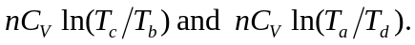 b) The total entropy change for one cycle is the sum of the entropy changes found in part (a); the other processes in the cycle are adiabatic, with Q = 0 and 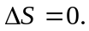The total is then
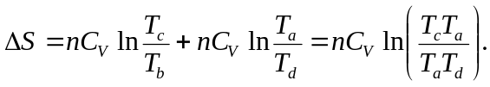
From the derivation of Eq. (20.6), 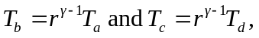 and so the argument of the logarithm in the expression for the net entropy change is 1 identically, and the net entropy change is zero. c) The system is not isolated, and a zero change of entropy for an irreversible system is certainly possible.

